Everything works! Caveat, deleting an object is by row. Could have easily redone the search function to delete by object but it was much easier to display the small table and delete by row. Not feasible for larger hash tables.

1. Adding and Removing Two Objects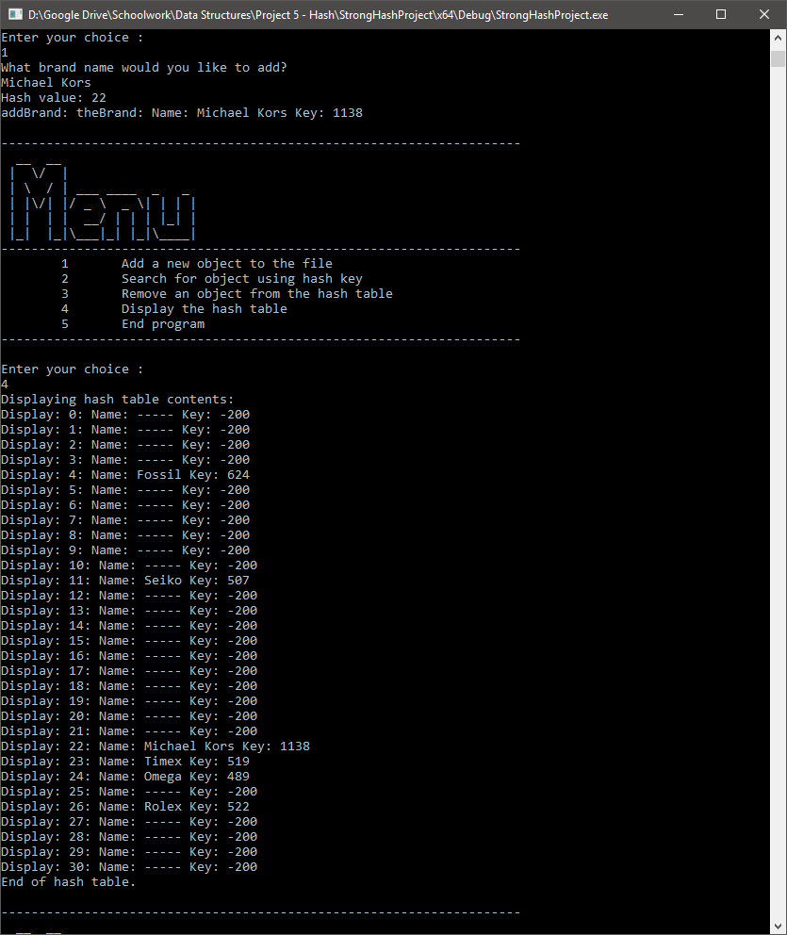

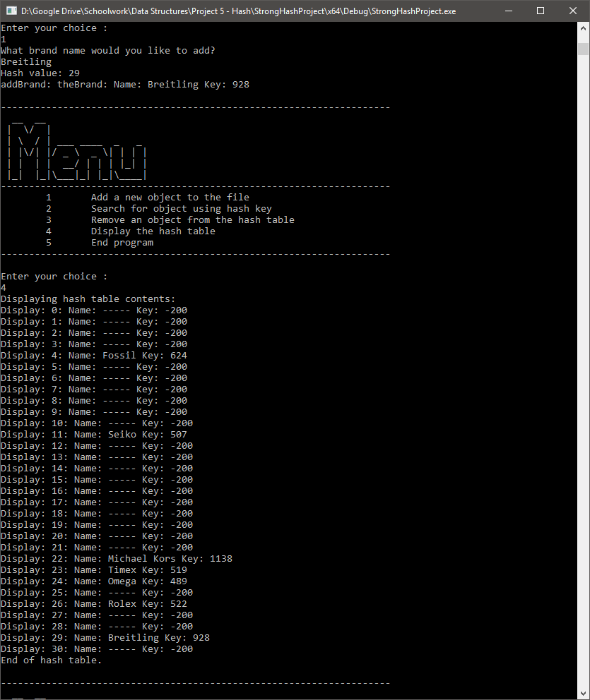

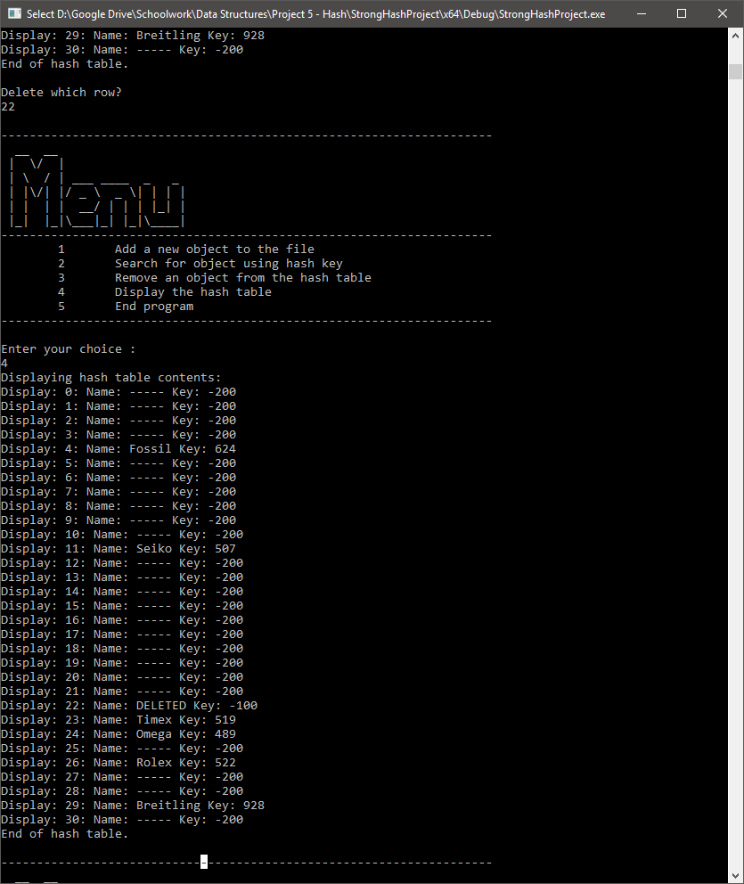

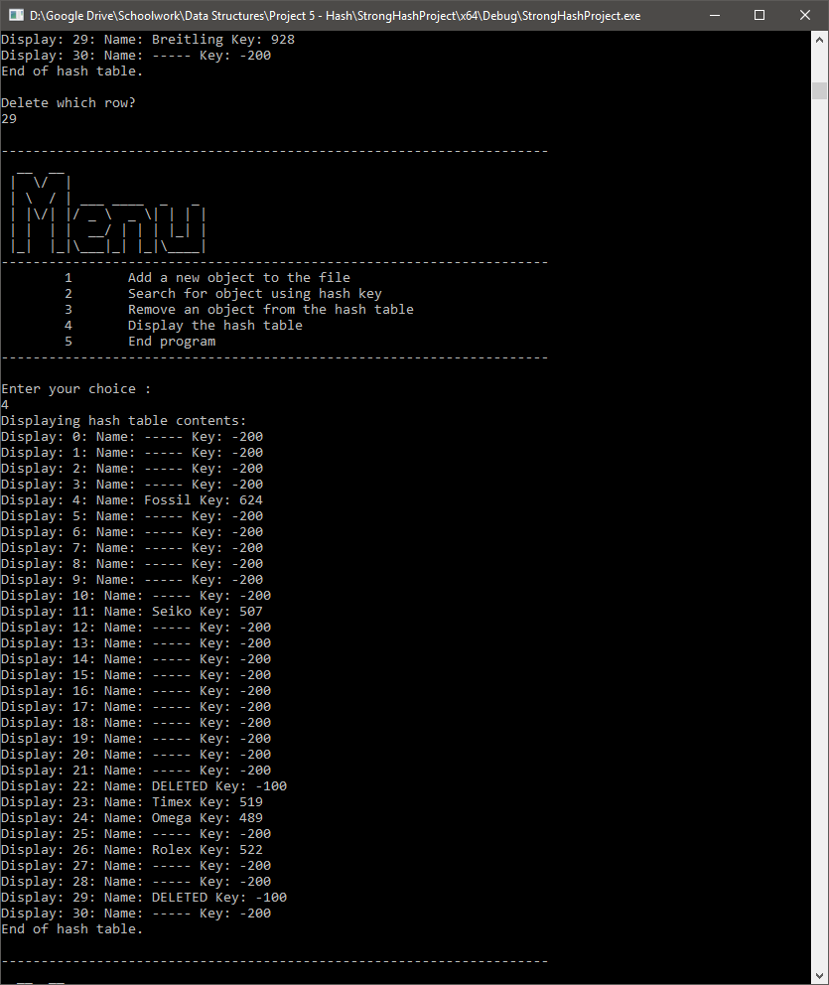

1. How An Object is Added to My Hash Table

When a user chooses to add a watch brand, it requests a brand name from them. From there it creates an object with the brand name as the name of the object. The constructor for this object sums up the ASCII values of the name and assigns this value to a key for the object. This object is then attempted to be placed into the hash table by position of key % FILE_SIZE inside of a while loop. If this row is not addable, the while loop increments a counter and the position is moved forward by quadratic probing, that is, when i is 1 then added to the position is 1*1, when i is 2 then added to the position is 2*2, etc. If the position exceeds the file size then it subtracts the file size from the position so that it “overflows” to the beginning of the hash table. If the hash table is a prime number then this ensures that all positions on the hash table are eventually filled up.

For instance,

* It adds Timex which is key 519.
* 519 converts to position 23.
* If we add “ddddw” which also converts to 519
* Tries to add it to position 23, but it’s taken by Timex
* It adds 1^2 to position 23 = position 24.
* Tries to add it to position 24, but It’s taken by Omega
* It adds 2^2 to position 24 = position 28.
* It is empty and successful
  + If it were to be filled and roll over to position 37 it subtracts 31 and tries to add to position 6